Name – Aditya Sushil Bedve

Form no – 240500064

Collage name – Cdac kharghar

**Navigate and List:**

a. Start by navigating to your home directory and list its contents. Then, move into a

directory named "LinuxAssignment" if it exists; otherwise, create it.

cdac@LAPTOP-A0LC5GAQ:/home$ ls

cdac

cdac@LAPTOP-A0LC5GAQ:/home$ cd cdac

cdac@LAPTOP-A0LC5GAQ:~$ mkdir linuxAssingment

cdac@LAPTOP-A0LC5GAQ:~$ ls

linuxAssingment

cdac@LAPTOP-A0LC5GAQ:~$

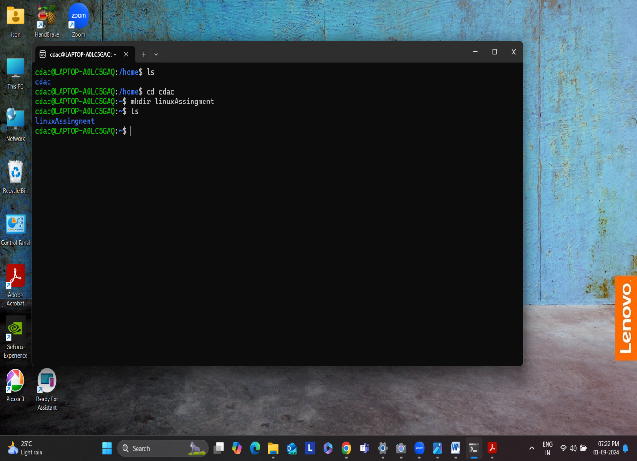**File Management:**

Inside the "LinuxAssignment" directory, create a new file named "file1.txt". Display its

contents.

cdac@LAPTOP-A0LC5GAQ:/home$ ls

cdac

cdac@LAPTOP-A0LC5GAQ:/home$ cd cdac

cdac@LAPTOP-A0LC5GAQ:~$ mkdir linuxAssingment

cdac@LAPTOP-A0LC5GAQ:~$ ls

linuxAssingment

cdac@LAPTOP-A0LC5GAQ:~$ nano file1.txt

cdac@LAPTOP-A0LC5GAQ:~$ cat file1.txt

Hello

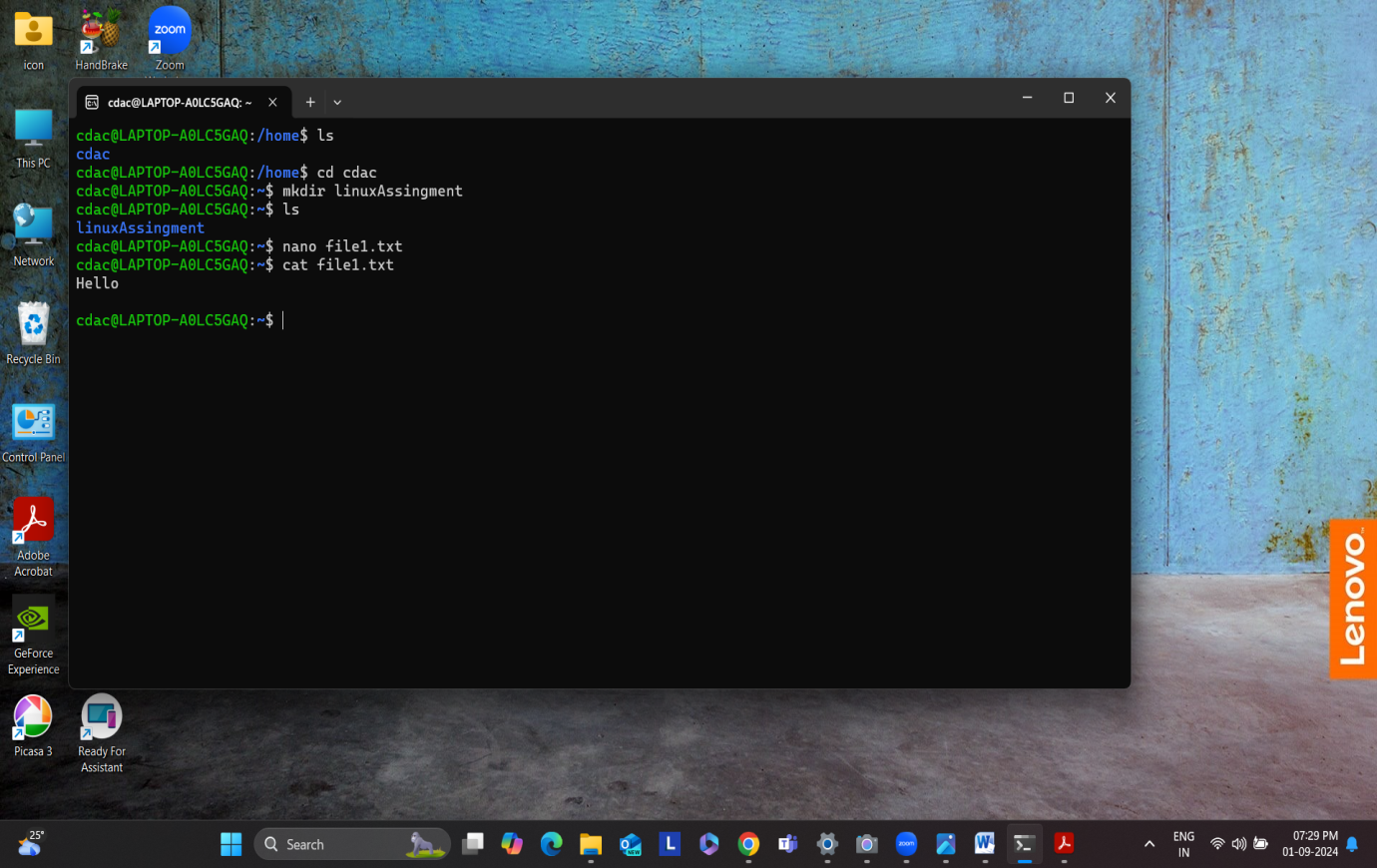

**Directory Management:**

a. Create a new directory named "docs" inside the "LinuxAssignment" directory.

cdac@LAPTOP-A0LC5GAQ:/home$ ls

cdac

cdac@LAPTOP-A0LC5GAQ:/home$ cd cdac

cdac@LAPTOP-A0LC5GAQ:~$ ls

file1.txt linuxAssingment

cdac@LAPTOP-A0LC5GAQ:~$ cd linuxAssingment

cdac@LAPTOP-A0LC5GAQ:~/linuxAssingment$ mkdir docs

cdac@LAPTOP-A0LC5GAQ:~/linuxAssingment$ ls

docs

cdac@LAPTOP-A0LC5GAQ:~/linuxAssingment$

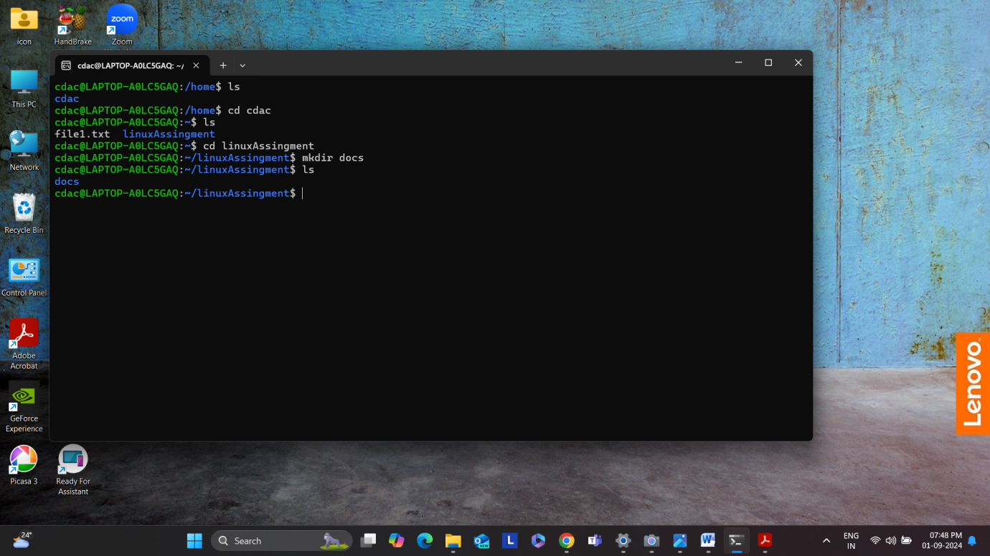

**Copy and Move Files:**

a. Copy the "file1.txt" file into the "docs" directory and rename it to "file2.txt".

cdac@LAPTOP-A0LC5GAQ:~/linuxAssingment/docs$ pwd

/home/cdac/linuxAssingment/docs

cdac@LAPTOP-A0LC5GAQ:~/linuxAssingment/docs$ cd cdac

-bash: cd: cdac: No such file or directory

cdac@LAPTOP-A0LC5GAQ:~/linuxAssingment/docs$ cd home

-bash: cd: home: No such file or directory

cdac@LAPTOP-A0LC5GAQ:~/linuxAssingment/docs$ cd /home

cdac@LAPTOP-A0LC5GAQ:/home$ cd cdac

cdac@LAPTOP-A0LC5GAQ:~$ cd linuxAssingment

cdac@LAPTOP-A0LC5GAQ:~/linuxAssingment$ ls

docs file1.txt

cdac@LAPTOP-A0LC5GAQ:~/linuxAssingment$ cp file1.txt docs

cdac@LAPTOP-A0LC5GAQ:~/linuxAssingment$ cd docs

cdac@LAPTOP-A0LC5GAQ:~/linuxAssingment/docs$ ls

file1.txt

cdac@LAPTOP-A0LC5GAQ:~/linuxAssingment/docs$ mv old_file1.txt new_file2.txt

mv: cannot stat 'old_file1.txt': No such file or directory

cdac@LAPTOP-A0LC5GAQ:~/linuxAssingment/docs$ mv file1.txt file2.txt

cdac@LAPTOP-A0LC5GAQ:~/linuxAssingment/docs$ ls

file2.txt

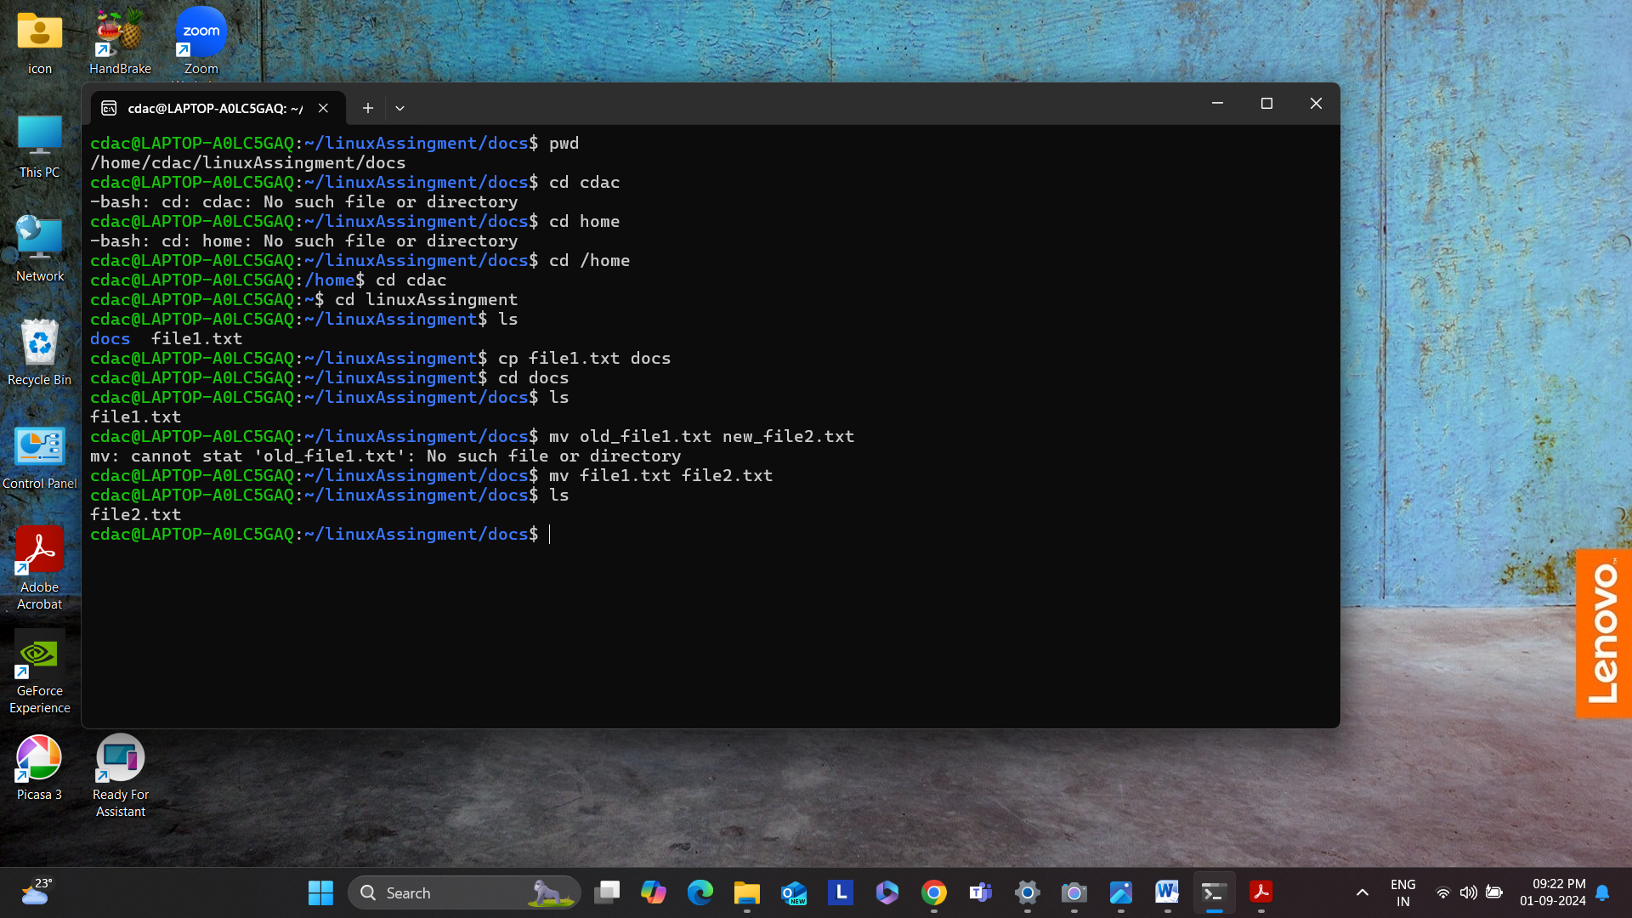

**Permissions and Ownership:**

a. Change the permissions of "file2.txt" to allow read, write, and execute permissions for

the owner and only read permissions for others. Then, change the owner of "file2.txt" to

the current user.

cdac@LAPTOP-A0LC5GAQ:~/linuxAssingment/docs$ pwd

/home/cdac/linuxAssingment/docs

cdac@LAPTOP-A0LC5GAQ:~/linuxAssingment/docs$ cd docs

-bash: cd: docs: No such file or directory

cdac@LAPTOP-A0LC5GAQ:~/linuxAssingment/docs$ cd /home

cdac@LAPTOP-A0LC5GAQ:/home$ cd cdac

cdac@LAPTOP-A0LC5GAQ:~$ cd linuxAssingment

cdac@LAPTOP-A0LC5GAQ:~/linuxAssingment$ ls

docs file1.txt

cdac@LAPTOP-A0LC5GAQ:~/linuxAssingment$ cd docs

cdac@LAPTOP-A0LC5GAQ:~/linuxAssingment/docs$ ls

file2.txt

cdac@LAPTOP-A0LC5GAQ:~/linuxAssingment/docs$ ls -l

total 4

-rw-r--r-- 1 cdac cdac 6 Sep 1 21:13 file2.txt

cdac@LAPTOP-A0LC5GAQ:~/linuxAssingment/docs$ chown u+x file2.txt

chown: invalid user: ‘u+x’

cdac@LAPTOP-A0LC5GAQ:~/linuxAssingment/docs$ chmod u+x file2.txt

cdac@LAPTOP-A0LC5GAQ:~/linuxAssingment/docs$ ls -l

total 4

-rwxr--r-- 1 cdac cdac 6 Sep 1 21:13 file2.txt

cdac@LAPTOP-A0LC5GAQ:~/linuxAssingment/docs$

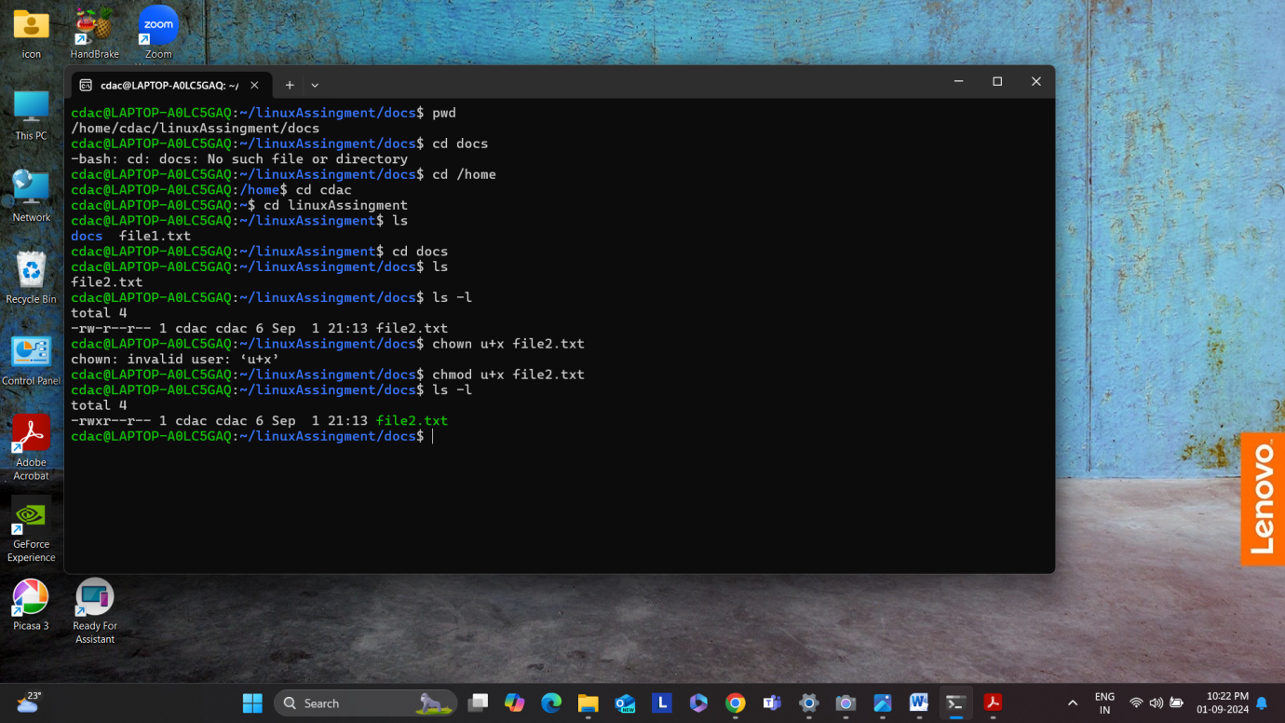

**Final Checklist:**

a. Finally, list the contents of the "LinuxAssignment" directory and the root directory to

ensure that all operations were performed correctly.

cdac@LAPTOP-A0LC5GAQ:~/linuxAssingment/docs$ pwd

/home/cdac/linuxAssingment/docs

cdac@LAPTOP-A0LC5GAQ:~/linuxAssingment/docs$ cd docs

-bash: cd: docs: No such file or directory

cdac@LAPTOP-A0LC5GAQ:~/linuxAssingment/docs$ cd /home

cdac@LAPTOP-A0LC5GAQ:/home$ cd cdac

cdac@LAPTOP-A0LC5GAQ:~$ cd linuxAssingment

cdac@LAPTOP-A0LC5GAQ:~/linuxAssingment$ ls

docs file1.txt

cdac@LAPTOP-A0LC5GAQ:~/linuxAssingment$ cd docs

cdac@LAPTOP-A0LC5GAQ:~/linuxAssingment/docs$ ls

file2.txt

cdac@LAPTOP-A0LC5GAQ:~/linuxAssingment/docs$ ls -l

total 4

-rw-r--r-- 1 cdac cdac 6 Sep 1 21:13 file2.txt

cdac@LAPTOP-A0LC5GAQ:~/linuxAssingment/docs$ chown u+x file2.txt

chown: invalid user: ‘u+x’

cdac@LAPTOP-A0LC5GAQ:~/linuxAssingment/docs$ chmod u+x file2.txt

cdac@LAPTOP-A0LC5GAQ:~/linuxAssingment/docs$ ls -l

total 4

-rwxr--r-- 1 cdac cdac 6 Sep 1 21:13 file2.txt

cdac@LAPTOP-A0LC5GAQ:~/linuxAssingment/docs$



**System Information:**

a. Display the current system date and time.

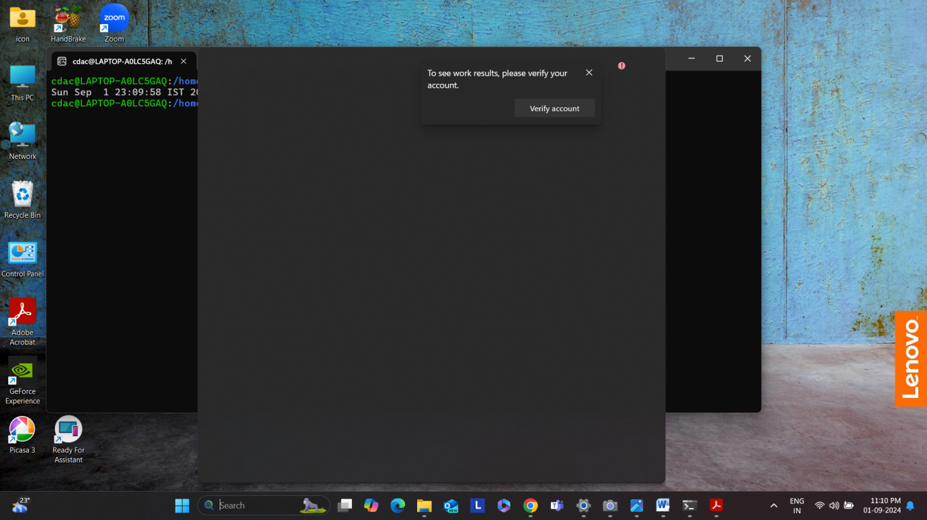

**A. Suppose you have a file named "data.txt" containing important information. Display the**

**first 10 lines of this file to quickly glance at its contents using a command.**

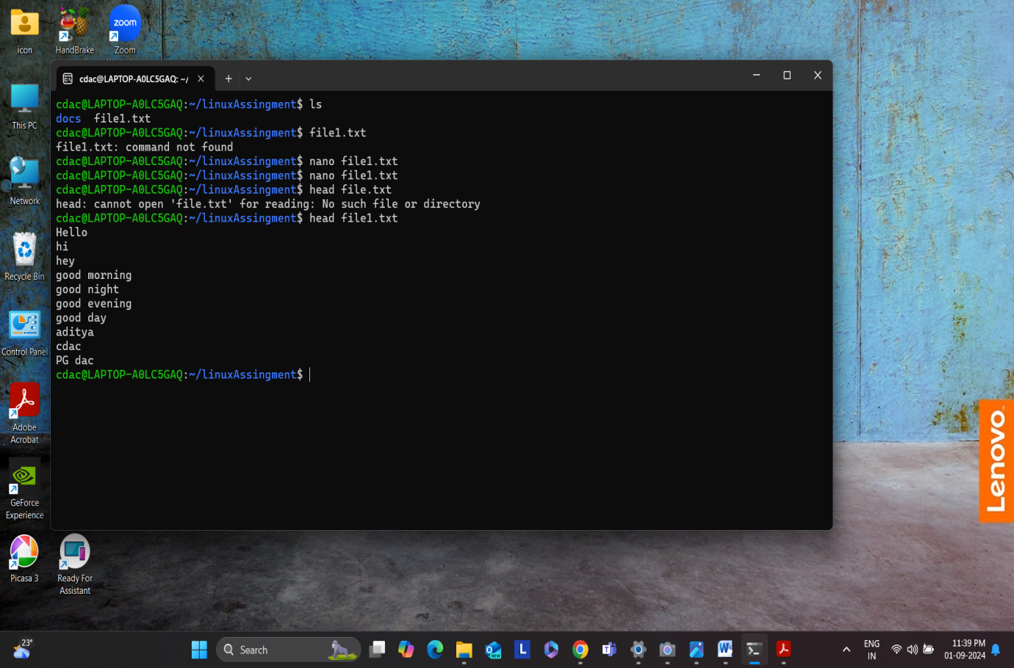

**b. Now, to check the end of the file for any recent additions, display the last 5 lines of**

**"data.txt" using another command.**

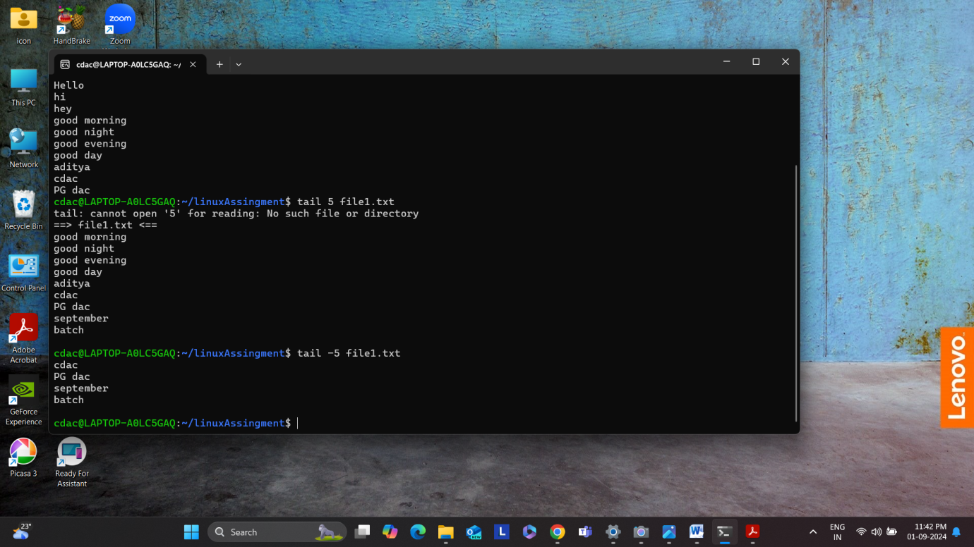

**3 In a file named "numbers.txt," there are a series of numbers. Display the first 15 lines of**

**this file to analyze the initial data set.**

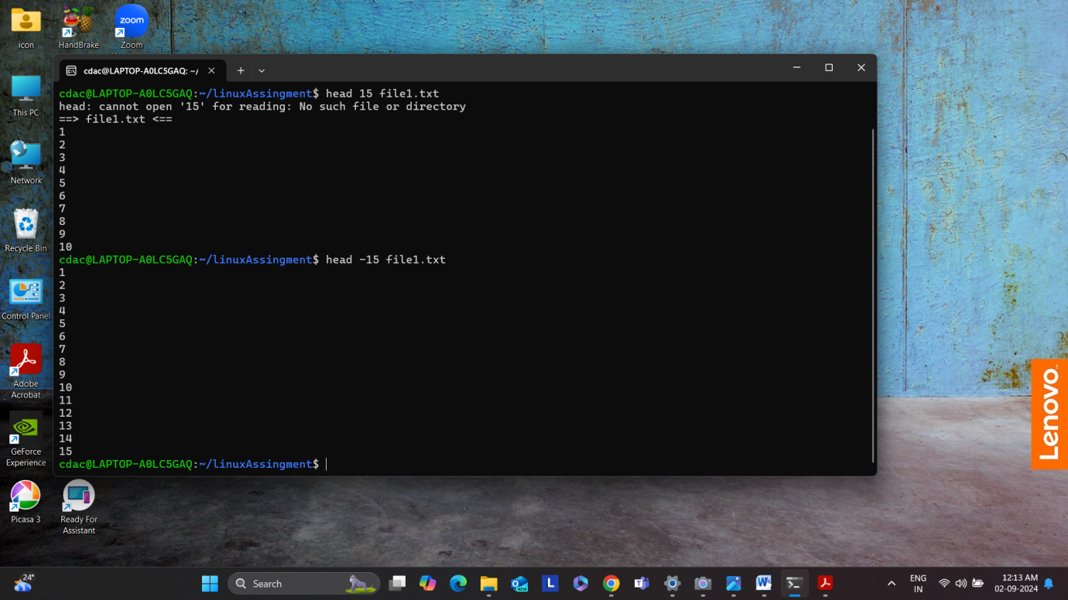

**d. To focus on the last few numbers of the dataset, display the last 3 lines of "numbers.txt".**

